21 April 2026

[ec2-user@ip-172-31-46-119 ~]$ sudo su -
[root@ip-172-31-46-119 ~]# ll
total 0
[root@ip-172-31-46-119 ~]# cd /opt/
[root@ip-172-31-46-119 opt]# vim input.txt

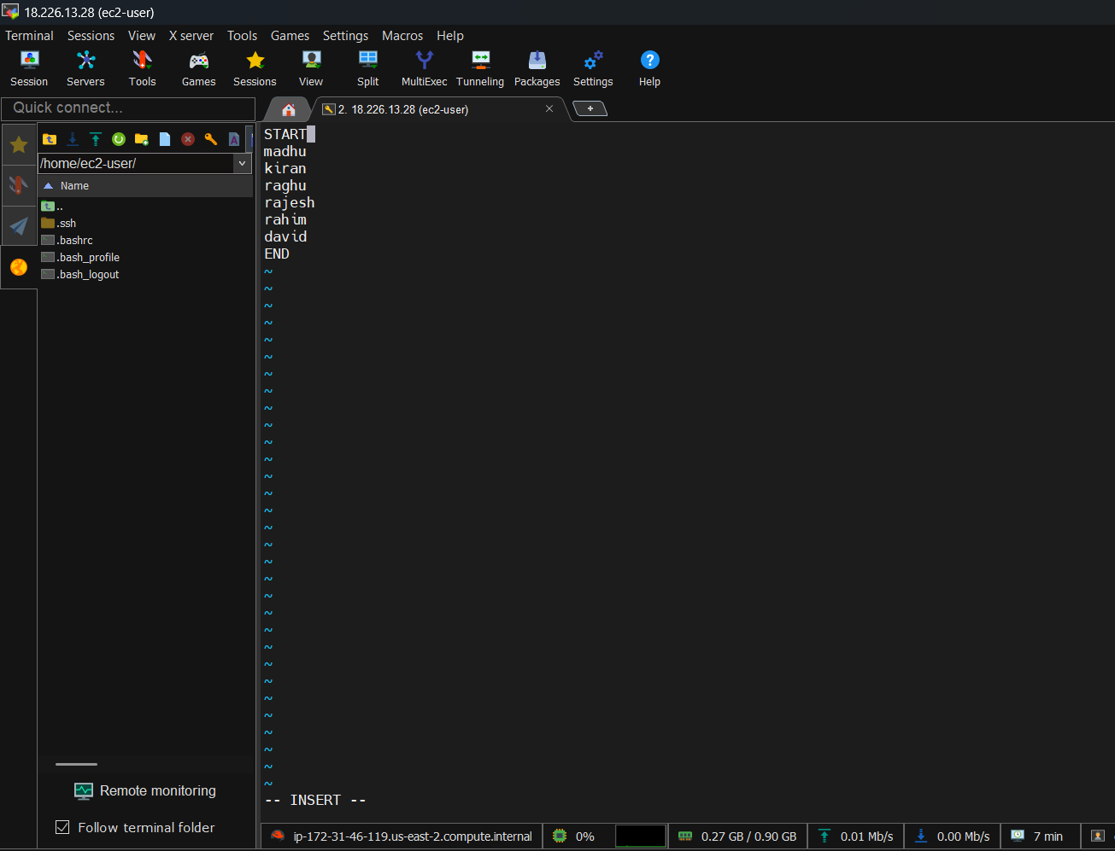

[root@ip-172-31-46-119 opt]# cat input.txt
START
madhu
kiran
raghu
rajesh
rahim
david
END
[root@ip-172-31-46-119 opt]# sed -i '/START/,/END/c\BATCH17D' input.txt
[root@ip-172-31-46-119 opt]# cat input.txt
BATCH17D
[root@ip-172-31-46-119 opt]# df -Th
Filesystem Type Size Used Avail Use% Mounted on
devtmpfs devtmpfs 4.0M 0 4.0M 0% /dev
tmpfs tmpfs 459M 0 459M 0% /dev/shm
tmpfs tmpfs 184M 440K 183M 1% /run
/dev/nvme0n1p1 xfs 8.0G 1.6G 6.4G 20% /
tmpfs tmpfs 459M 0 459M 0% /tmp
/dev/nvme0n1p128 vfat 10M 1.3M 8.7M 13% /boot/efi
tmpfs tmpfs 92M 0 92M 0% /run/user/1000
[root@ip-172-31-46-119 opt]# mount -o remount,size=4G /tmp
[root@ip-172-31-46-119 opt]# df -Th
Filesystem Type Size Used Avail Use% Mounted on
devtmpfs devtmpfs 4.0M 0 4.0M 0% /dev
tmpfs tmpfs 459M 0 459M 0% /dev/shm
tmpfs tmpfs 184M 440K 183M 1% /run
/dev/nvme0n1p1 xfs 8.0G 1.6G 6.4G 20% /
tmpfs tmpfs 4.0G 0 4.0G 0% /tmp
/dev/nvme0n1p128 vfat 10M 1.3M 8.7M 13% /boot/efi
tmpfs tmpfs 92M 0 92M 0% /run/user/1000
[root@ip-172-31-46-119 opt]# sudo yum update –y
sudo wget -O /etc/yum.repos.d/jenkins.repo \
https://pkg.jenkins.io/rpm-stable/jenkins.repo
sudo rpm --import https://pkg.jenkins.io/rpm-stable/jenkins.io-2026.key
sudo yum upgrade -y
sudo yum install java-21-amazon-corretto -y
sudo yum install jenkins -y
sudo systemctl enable jenkins
sudo systemctl start jenkins

